# INP301x Development Board

## Jumpers on the Board

Figure 3: INP301x EVB-A control and connectivity points

|  |  |
| --- | --- |
| **Jumper** | **Mode and Operation** |
| J1 | IO header |
| J2 | Used to enable Console logging in shield mode |
| J3 | Connect LED D1 to GPIO14, for debug purposes |
| J4 | Select power from USB or battery connector, also used for current measurements |
| J7 | Connect SCL to GPIO4 |
| J8 | Connect SDA to GPIO3 |
| J9 | Select IO voltage for FTDI IOs |
| J10 | Battery terminal |
| J11 | Enable the multi-port SPDT switch |
| JP1 to JP4 | Arduino UNO shield compatible header (3.3V support only) |
| U3 | Switch between Stand-alone mode and Arduino Shield Mode |

Table 1: Jumper Information

## Power Supply and Mode Switch

The INP301x board is designed to supply power to the INP101x module in following ways:

1. In standalone mode, power is drawn from USB connector
2. In shield mode, power is drawn from shield connector
3. A battery header is also available to provide power to the module

Figure 4: Power supply section

The power supply section is shown in Figure 4. The INP101x module requires 3.3V supply. The DPDT switch (U3) selects between USB and Arduino header supply using the common net Vm_3.3V. The jumper J4 is used to select between battery supply and Vm_3.3V. The same jumper can be used for measuring current consumption of the module.

## IO Header (J1)

The J1 header brings out all the IOs from INP101x module. These IOs can be used for debug, and/or any external interfacing needs. The pinout of this header is shown in Figure 5. To work with on board sensor, pins 1 & 2 needs to be shorted.

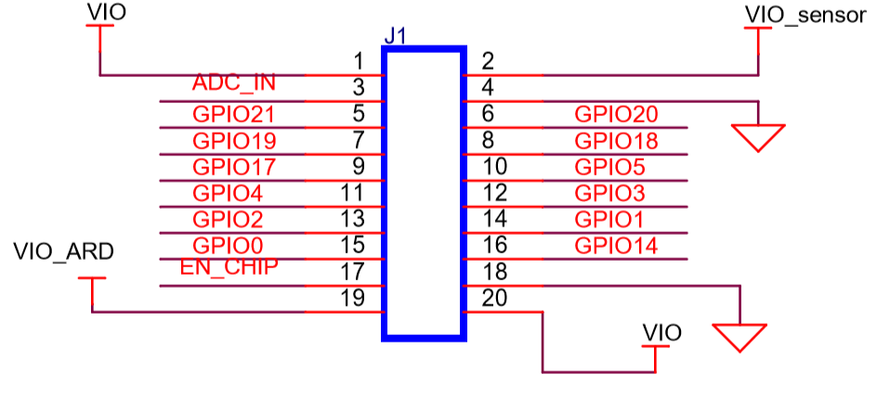

Figure 5: IO Header

## Shield Headers (JP1 to JP4)

Arduino UNO compatible headers are available in the INP301x board to interface with any compatible host micro-controller.

The GPIOs assigned to shield headers are carefully chosen to achieve following capability:

1. INP101x’s SPI slave pins available on JP1
2. INP101x’s I2C master pins available on JP1
3. Remaining GPIOs are available on JP2 and JP4

Note that INP301x supports 2.5V IO as the default configuration. The shield header connections are as shown in JP2 of Figure 6.

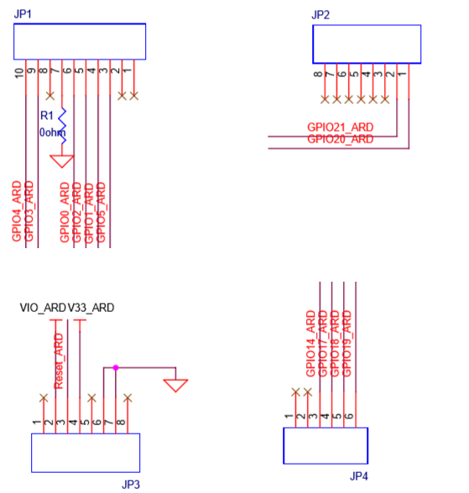

Figure 6: Arduino UNO shield compatible jumpers

## On Board Sensors

Figure 7: On board sensors

The INP301x board has following sensors available on board for quick prototyping/testing:

1. Temperature/Humidity (Sensirion SHTC3)
2. Pressure (Bosch BMP388)
3. Light (TI OPT3002)

To use the sensors, J7, J8, pins 1 & 2 of J1 should be connected. This enables power connection to the sensors on board, I2C connection on GPIOs 3 & 4.

# Functional Description

Following are the functional modes that can be achieved in the INP301x board:

1. Stand-alone mode (host-less)
2. Shield mode (hosted)

More details about each mode are available in subsequent sections. Switching between the modes is handled by DPDT switch U3 for power, and multi-port SPDT switch U1 for the GPIOs.

## Stand-alone Mode

The stand-alone mode is intended for following use cases:

1. Host-less application development on INP101x modules
2. Programing access to INP101x modules

In stand-alone mode, the U3 switch is pushed towards pin 3, which disconnects power and IO from shield headers and connects them to FTDI. The FTDI port layout is shown in Table 2.

|  |  |
| --- | --- |
| **FTDI Bus** | **Interface to Talaria TWO** |
| A | JTAG |
| B | RESET |
| C | UART |
| D | CONSOLE (UART) |

Table 2: FTDI Layout

The A & B bus of FTDI device supports MPSEE protocol, hence JTAG is assigned to A-bus. The BDBUS7 is connected EN_CHIP of the INP101x module. The C & D bus of FTDI device used as UARTs, with C-bus connected to peripheral UART of INP101x module and D-bus connected is CONSOLE port (GPIO17) of INP101x module.

The JTAG on A-bus is used for debugging applications on the INP101x module. The UART on C-bus is used for programming the INP101x module. The CONSOLE port is a unidirectional UART from INP101x module that operates at high baud rate of 2457600, used for debug prints.

## Shield Mode

This mode will make the EVB-A board to act as a Wi-Fi/BLE5 shield. To enable this mode, flip the switch U3 towards V33_ARD. This also pulls up the INA pin of the multi-port SPDT device MAX4761ETX, which then routes the GPIOs from the INP101x module to the shield headers JP1, JP2, JP3 and JP4. In the shield mode a suitable firmware (such as Serial to Wi-Fi application available in the SDK) should be pre-flashed in the INP101x.

### EVB-A as Wi-Fi Shield with STM32 Nucleo Board

A comprehensive set of host application packages are available to download via the InnoPhase website to demonstrate the use of EVB-A as a Wi-Fi/BLE5 shield board.

Mount the Talaria TWO EVB on the STM32 board on Arduino connector. Connect GPIO4 of Talaria TWO (J1 Connector) to Pin2 of CN6 connector. Talaria TWO uses this GPIO4 pin to interrupt ST when Talaria TWO wants to send data/notification to ST.

Figure 8: INP3010 EVB-A as Wi-Fi Shield

# Antenna

The antennas integrated with INP2045 are listed in Table 3 have been approved for FCC/ISED, EU(RED) and TELEC.

|  |  |  |  |  |
| --- | --- | --- | --- | --- |
| **Module ID** | **Antenna Type** | **Model Number** | **Antenna Manufacturer** | **Max Peak Antenna Gain (dBi)** |
| INP1010 | PCB Antenna | INP1010 PCB TRACE | InnoPhase | 0.9 |
| INP1011 | SMA Antenna (External Antenna) | W24-ASMA-M | Inventek | 2.15 |
| INP1012 | SMA Antenna (External Antenna) | W24-ASMA-M | Inventek | 2.15 |
| INP1013 | SMD Chip Antenna | 2450AT42B100 | Johanson | 0 |
| INP1014 | PCB Antenna | 1014 PCB Trace | InnoPhase | 5.33 |
| INP1015 | SMA Antenna (External Antenna) | W24-ASMA-M | Inventek | 2.15 |

Table 3: Module ID with Antenna details

## INP1010

Talaria TWO INP1010 module has a proprietary integrated/printed antenna. It is a Double-sided Inverted F (IFA) antenna and has been implemented as printed PCB elements.

By design and verification, Antenna does not require any additional matching component if the module is used as standalone product. This INP1010 PCB antenna integrated with INP2045 has been approved for FCC/ISED, EU(RED) and TELEC.

|  |  |  |  |
| --- | --- | --- | --- |
| **Module ID** | **Antenna Type** | **Model Number** | **Max Peak Antenna Gain (dBi)** |
| INP1010 | PCB Antenna | INP1010 PCB TRACE | 0.9 |

Table 4: INP1010 - Antenna specifications

## INP1011/INP1012/INP1015

Talaria TWO INP1011/INP1012/INP1015 module has been certified with External SMA antenna W24-ASMA-M which has been approved for FCC/ISED, EU(RED) and TELEC.

|  |  |  |  |
| --- | --- | --- | --- |
| **Module ID** | **Antenna Type** | **Model Number** | **Max Peak Antenna Gain (dBi)** |
| INP1011/012/015 | SMA Antenna (External Antenna) | W24-ASMA-M | 2.15 |

Table 5: INP1011/012/015 - Antenna specifications

## INP1013

Talaria TWO INP1013 module has been certified with SMD chip antenna 2450AT42B100 which has been approved for FCC/ISED and TELEC.

|  |  |  |  |
| --- | --- | --- | --- |
| **Module ID** | **Antenna Type** | **Model Number** | **Max Peak Antenna Gain (dBi)** |
| INP1013 | SMD chip antenna | 2450AT42B100 | 0 |

Table 6: INP1013 - Antenna specifications

## INP1014

Talaria TWO INP1014 module has a proprietary integrated/printed PCB antenna. By design and verification, antenna does not require any additional matching components if the module is used as a stand-alone product. INP1014 PCB antenna integrated with INP2045 has been approved for FCC/ISED and TELEC.

|  |  |  |  |
| --- | --- | --- | --- |
| **Module ID** | **Antenna Type** | **Model Number** | **Max Peak Antenna Gain (dBi)** |
| INP1014 | PCB Antenna | 1014 PCB Trace | 5.33 |

Table 7: INP1014 Antenna specifications